InstaCart Market Basket Analysis:

Sriprasath Gujuluva Parthasarathy

Frequent items for products in orders dataset. You have to output product names and not just product id:

Item Frequency plot:

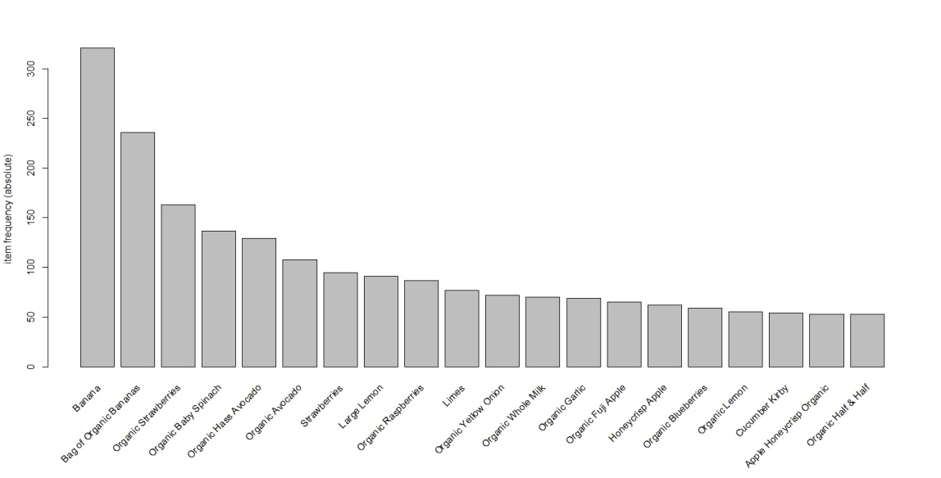

Hence it seems that Banana has the highest item frequency from the taken dataset.

Association rules for products in orders dataset. You have to output product names and not just product id

Association Rules:

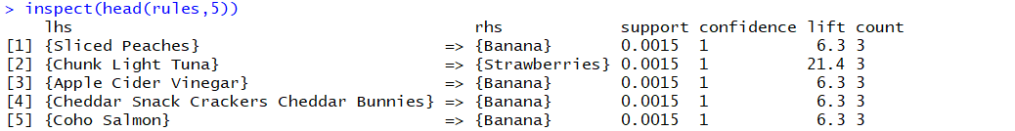

Association Rules after sorting by lift:

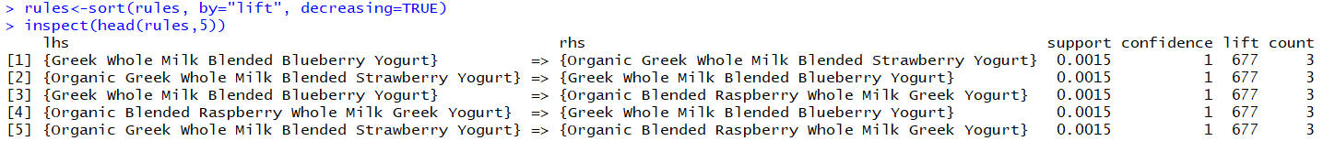

So from above it is clear that the Association rule {Greek Whole Milk Blended Blueberry Yogurt} => {Organic Greek Whole Milk Blended Strawberry Yogurt} has the highest lift value in the taken dataset.

The support and confidence value used is 0.001 and 0.8 respectively.

Frequent items for departments in orders dataset (i.e which departments have highest number of orders). You have to output department names and not just department id

Item Frequency plot:

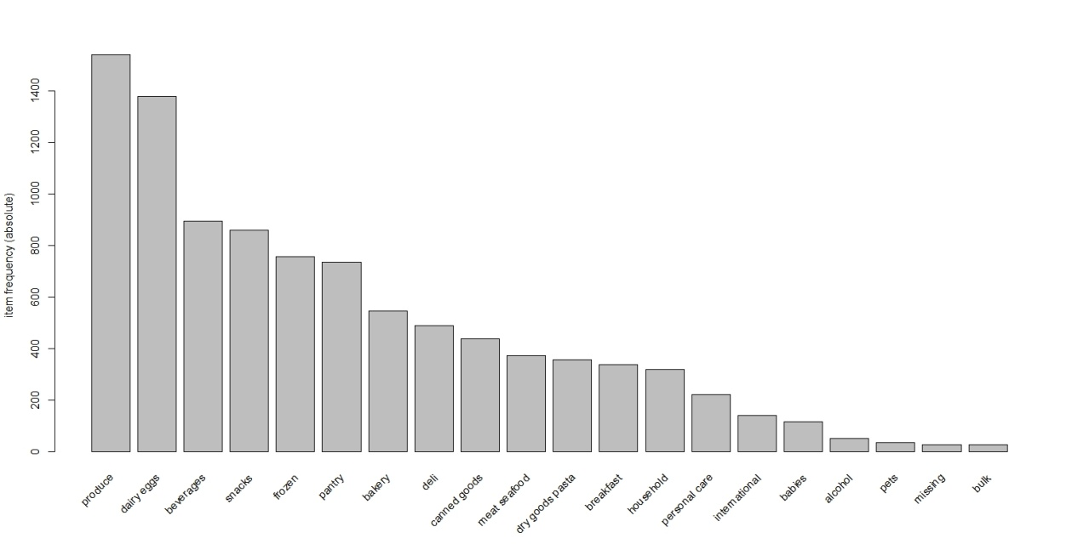

So from above it is clear that produce department has the highest frequency in the taken dataset.

Association rules for departments in orders dataset (e.g. frozen -> groceries). You have to output department names and not just department id:

Association Rules:

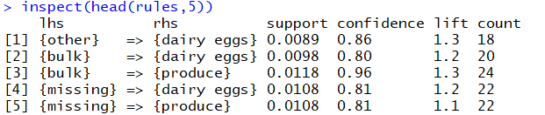

Association Rules after sorting by lift:

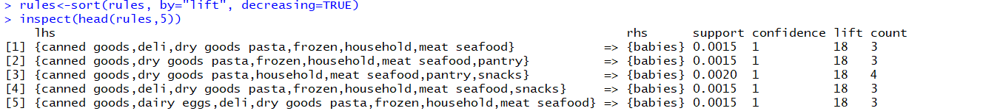

From above it is clear that the association rule {canned goods,deli,dry goods pasta, frozen, household, meat seafood} => {babies} has the highest lift value in the taken dataset. The support and confidence value used is 0.001 and 0.8 respectively.